**Implemention/Analysis of Frequency Modulated and Demodulated Signal using Matlab**

**Lab # 07**



**Fall 2023**

**CSE-402L Digital Signal Processing Lab**

Submitted by: **MUHAMMAD SHAHAB**

Registration No.: **21PWCSE2074**

Class Section: **C**

“On my honor, as student of University of Engineering and Technology, I have neither given nor received unauthorized assistance on this academic work.”

Submitted to:

**Dr. Yasir Saleem Afridi**

Date:

**11th December 2023**

**Department of Computer Systems Engineering**

**University of Engineering and Technology, Peshawar**

**CSE 402L: Digital Signal Processing**

|  |  |  |  |  |
| --- | --- | --- | --- | --- |
| **Demonstration of Concepts** | **Poor (Does not meet expectation (1))**  The student failed to demonstrate a clear understanding of the assignment concepts | **Fair (Meet Expectation (2-3))**  The student demonstrated a clear understanding of some of the assignment concepts | **Good (Exceeds Expectation (4-5)**  The student demonstrated a clear understanding of the assignment concepts | **Score**  **30%** |
| **Accuracy** | The student completed ( <50%) tasks and provided MATLAB code and/or Simulink models with errors. Outputs shown are not correct in form of graphs (no labels) and/or tables along with incorrect analysis or remarks. | The student completed partial tasks (50% - <90%) with accurate MATLAB code and/or Simulink models. Correct outputs are shown in form of graphs (without labels) and/or tables along with correct analysis or remarks. | The student completed all required tasks (90%-100%) with accurate MATLAB code and/or Simulink models. Correct outputs are shown in form of labeled graphs and/or tables along with correct analysis or remarks. | **30%** |
| **Following Directions** | The student clearly failed to follow the verbal and written instructions to successfully complete the lab | The student failed to follow the some of the verbal and written instructions to successfully complete all requirements of the lab | The student followed the verbal and written instructions to successfully complete requirements of the lab | **20%** |
| **Time Utilization** | The student failed to complete even part of the lab in the allotted amount of time | The student failed to complete the entire lab in the allotted amount of time | The student completed the lab in its entirety in the allotted amount of time | **20%** |

Implemention/Analysis of Frequency Modulated and Demodulated Signal using Matlab

A sine wave carrier can be modified for the purpose of transmitting information from one place to another by varying its frequency. This is known as **frequency modulation (FM).**

Frequency modulation (FM) is the standard technique for high-fidelity communications as is evident in the received signals of the FM band (88-108 MHz) vs. the AM band (450-1650 KHz). The main reason for the improved fidelity is that FM detectors, when properly designed, are not sensitive to random amplitude variations which are the dominant part of electrical noise (heard as static on the AM radio). Frequency modulation is not only used in commercial radio broadcasts, but also in police and hospital communications, emergency channels, TV sound, wireless (cellular) telephone systems.



νAM = *Vc*sin 2π*fct* + (*Vm*sin 2π*fmt*)(sin 2π*fct*)

Tasks:

1. Set the sampling frequency to 1kHz and carrier frequency to 200 Hz. Generate a time vector having a duration of 0.2 s.

fs = 1000; % Sampling Frequency

fc = 200; % Carrier Frequency

t = (0:1/fs:0.2)';

1. Create two tone sinusoidal signal with frequencies 30 and 60 Hz

x = sin(2*pi*30*t)+2*sin(2*pi*60*t);

1. Generate a Carrier Signal with the freq of 200Hz

yc = sin(2*pi*fc*t);

1. Plot the modulating Signal and Carrier Signal')

)

1. **Observe figure and comment on the frequencies of both signals and why.**
2. Set the frequency deviation to 50 Hz.

fDev = 50;

1. Frequency modulate x (Modulating Signal) using fmmod.

y = fmmod(x,fc,fs,fDev);

1. Plot the original and modulated signals.

plot(t,x,'c',t,y,'b--')

xlabel('Time (s)')

ylabel('Amplitude')

legend('Original Signal','Modulated Signal')

1. Compare and Contrast Figure 1 and Figure 2
2. Change FDev to 100 Hz. Obtain the output and plot it (let say Figure 3). **Compare and Contrast the output shown in Figure 2 and Figure 3**
3. Perform Frequency Demodulation using Matlab function fmdemod
4. Plot the original and demodulated signals

Full Code:

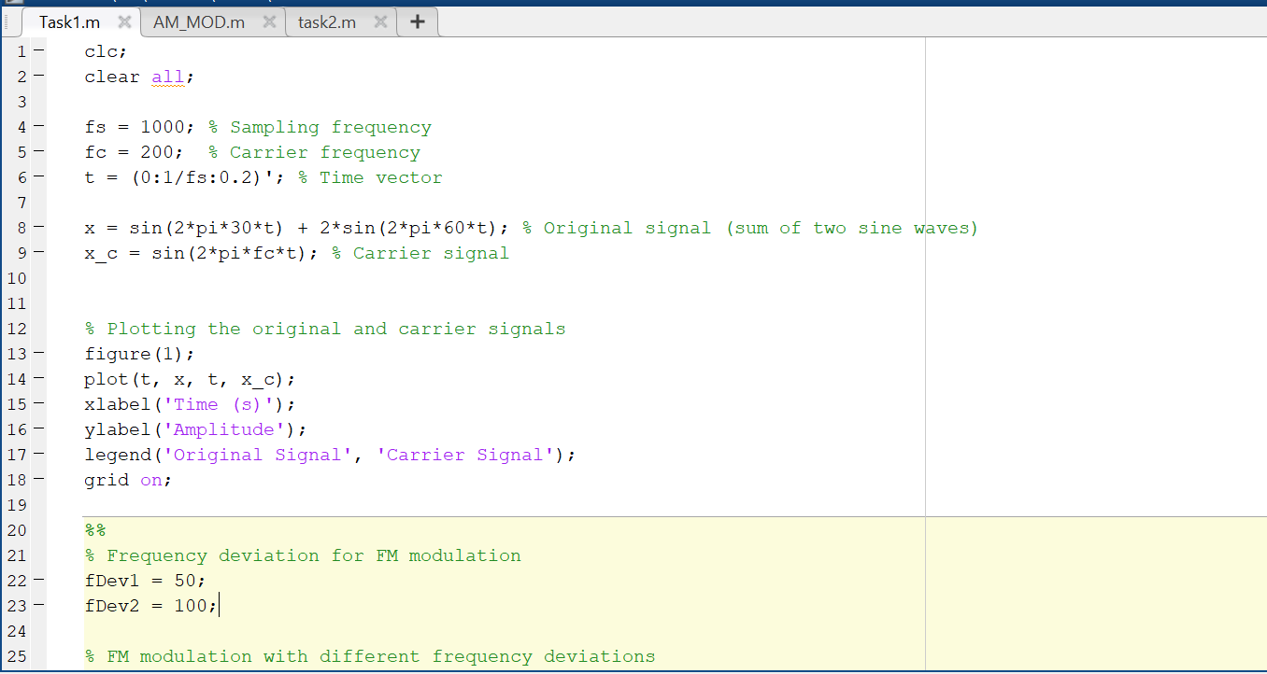

Output:

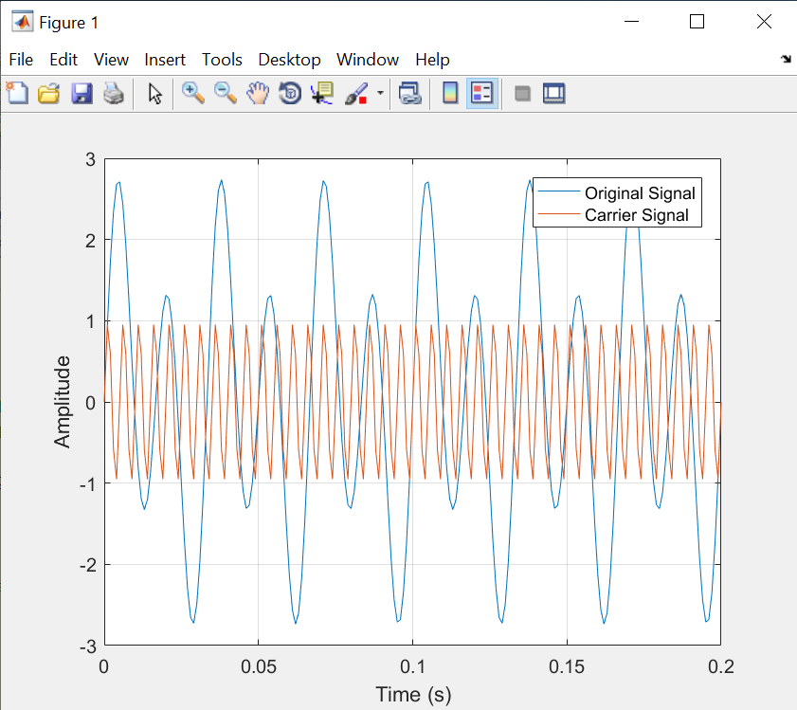

Figure 1

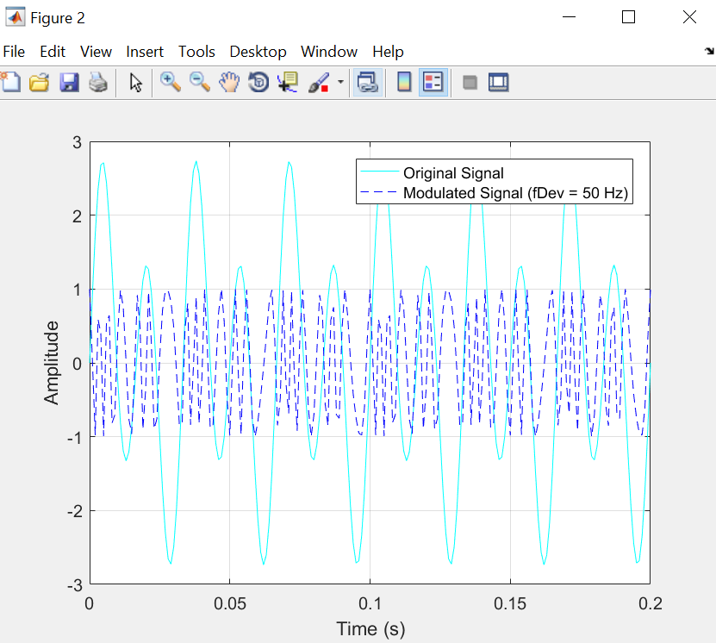

Figure 2

Figure 3

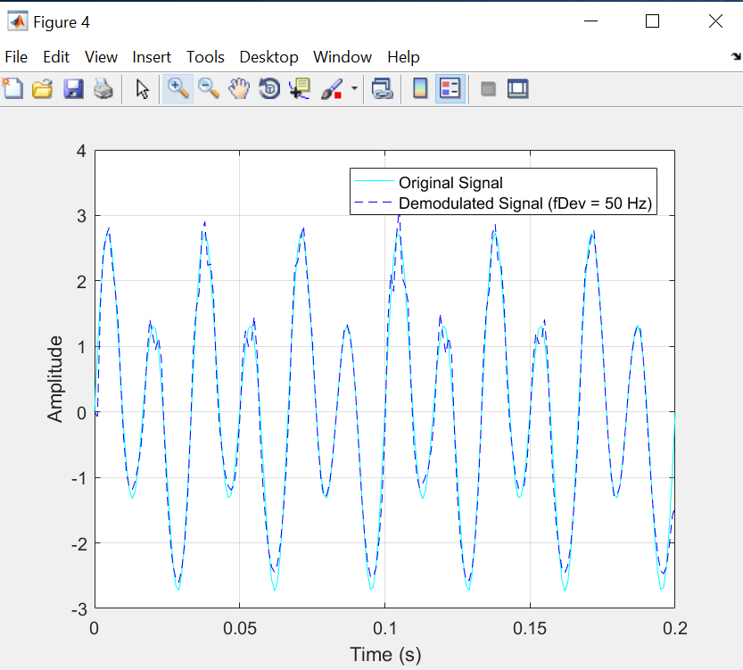

Figure 4

Figure 5

Observation:

It can be seen clearly from Figure 1, that Carrier Signal has high frequency (200 Hz) than the original message signal. Carrier signals complete more cycles in less time as compared to original signal.

By clearly analyzing Figure 2 and Figure 3, we can conclude that by doubling the fDev, the signal is distorted in the time domain and hence it deviates from the original signal when it is demodulated.